Effect of Hydrochloric acid on physicochemical characteristic ………………….Article Title
Anupong Jeerachaipansakul¹, Srisurang Suttapreyasri²…………………..Article author
¹The Cranio-Maxillofacial Hard Tissue Engineering Center
²Department of Oral and Maxillofacial surgery, Faculty of Dentistry, Prince of Songkla University, Hat Yai, Songkhla 90112, Thailand…………………………….Article institute
Abstract……………………………………………….Abstract heading

Background:The tooth increasingly attracts attention as a grafting material. There are many demineralization methods are used for preparing demineralized tooth matrix but
…………………………………………………………………………………………………………………………………………………
Objectives:…………………………….Abstract heading

Materials and methods:Caries-free permanent teeth were processed mechanically for preparation of human tooth matrix. The demineralized process was performed using ………………………………………………………………………………………………………………………………………………………………………………………………………………………………
…………………………………………………………………………Abstract content

Results:Increasing HCl reaction time led to more collagen exposed on smooth dentin surface, larger size of dentinal tubule and average pore diameter, less crystallinity, and ………………………………………………………………………………………………………………………………………………………………………………………………………………………………
………………………………………………………………………………………………………………
Conclusions:The reaction time of HCl has greater effect on hDTM more than the ………………………………………………………………………………………………………………………………………………………………………………………………………………………………
………………………………………………………………………………………………………………

Keywords:BMP-2, Bone graft, demineralization, Tooth matrix, Tooth particle
Introduction…………………………….Artcle heading
The tooth increasingly attracts attention as a grafting material. The tooth is a composite of an organic and inorganic component consisting of calcium phosphate, collagen, and other organic elements. The chemical………………………………………………………………………………………………………………
………………………………………………………………………………………………………………………………………………………………………………………………………………………………
………………………………………………………………………………………………………………
…………………………. Full text…………………………….
………………………………………………………………………………………………………………………………………………………………………………………………………………………………
HCl is the most common use for demineralization process because of the most rapid rates of demineralization with the highest dissociation constant and solubility of calcium salts(Morris & Benton 1956) and the lower risk for nearby tissue inflammation(Urist 1965).
………………………………………………………………………………………………………………………………………………………………………………………………………………………………
………………………………………………………………………………………………………………
The present study aimed to evaluate the effect of using different concentration and reaction time of HCl on the physical and chemical characteristics of human tooth matrix and to quantify the concentration of BMP-2 extracted from prepared demineralized tooth matrix.
Materials and methods
The study was performed at the Surgery clinic, Dental Hospital, Faculty of Dentistry, Prince of Songkla University. The experimental protocol was approved by the Human Research Ethics Committee of the Faculty of Dentistry, Prince of Songkla University.
Human tooth matrix preparation
Caries-free third molar or premolar permanent teeth were obtained from
………………………………………………………………………………………………………………
………………………………………………………………………………………………………………
(Fig1A, B) The cleaned teeth were pulverized by ball mill machine (Mixer Mill M301, Retsch GmbH, Haan, Germany). Siver with 500 µm and 1,000 µm aperture (Endecotts, London, UK) were used to collect the particle size. (Fig.1C)
………………………………………………………………………………………………………………

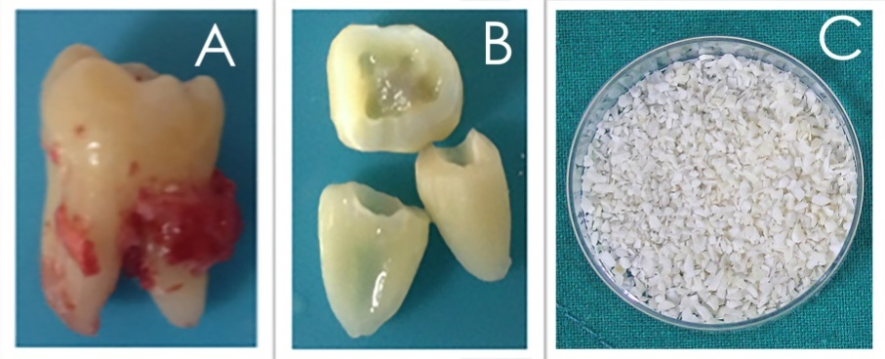
Figure
Figure 1 Gross appearance of an extracted human tooth (A). Cleaned tooth segments after mechanically soft tissue removal (B). Human tooth matrix (hTM) sized 500-1000 µm (C)……………………..Figure legend
The surface characteristics
The tooth matrix was dried, sputter-coated with gold thin film and viewed with SEM system (FEI Quanta 400, FEI Company, USA).
BET analysis
Brunauer-Emmett-Teller analysis (BET, Micromeritics ASAP2460, Micromeritics Instrument Corp, Atlanta, GA, USA) is used for describing the………………………………………………………………………………………………………………………………………………………………………………………………………………………………
………………………………………………………………………………………………………………
Analysis of crystallinity
……………………………………………………………………………………………………………………………………………………………………………………………………………………
………………………………………………………………………………………………………………………………………………………………………………………………………………………………………………………………………………………………………………………………………………
………………………………………………………………………………………………………………

Analysis of inorganic components
Elemental components in all groups wereanalyzed by X-Ray Fluorescence Spectrometer (PW 2400, Philips, Eindhoven, Netherlands).
Ca/P ratio
The stoichiometric Ca/P ratios were calculated using the following formula:…………………..………………………………………………………………………………
……………………………………………………….(Teruel Jde, et al. 2015).
Statistical analysis
Data were expressed as mean ± SD. IBM SPSS version 23 statistic software was used to analyze the data. The difference among groups was determined by one-way ANOVA and comparison between groups were carried out by post hoc Tukey HSD. P<0.05 was considered to be statistically significant.
Results
Particle characterization
The gross appearances of hTM and hDTM were shown in Figure 2. All tooth particles were whitish to yellow in color with hard in consistency. The hDTM in 20 minutes reaction time (0.5M 20min and 1.0M 20min) revealed less opacity.
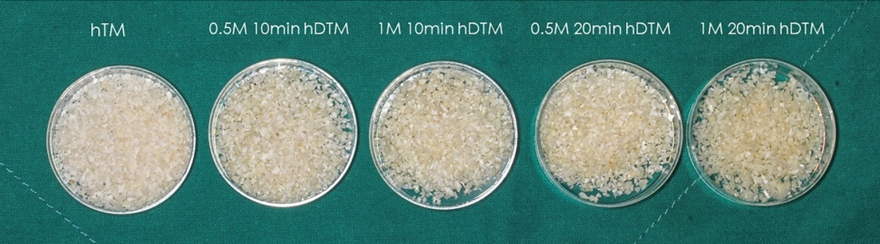
Figure 2 Gross appearance of the hTM and hDTM from 4 different demineralization protocols.
SEM analysis
The surface characteristics of hTM and hDTM were demonstrated in Figure 3. ………………………………………………………………………………………………………………………………………………………………………………………………………………………………
………………………………………………………………………………………………………………
XRF analysis
The demineralized process reduced the amount of Ca and P with the. (Table 1)
Table 1The element component (%) of hTM and hDTM samples determined using XRF………………………………………………….Table title
Groups | ......................... Table content. |  |  |  |  |  |  |  |  | - Ca/P ratio
 | Ca | P | S | Mg | Na | Cl | K | Zn | Fe
hTM | 15.6 | 8.08 | 0.04 | 0.42 | 0.50 | 0.08 | 0.01 | <0.01 | 0 | 1.492
0.5M 10min hDTM | 11 | 4.32 | 0.15 | 0.13 | 0.16 | 0.15 | <0.01 | <0.01 | 0 | 1.968
1M 10min hDTM | 8.25 | 2.71 | 0.19 | 0.01 | 0.15 | 0.17 | <0.01 | <0.01 | 0 | 2.352
0.5M 20min hDTM | 8.17 | 2.64 | 0.21 | 0.07 | 0.12 | 0.01 | <0.01 | <0.01 | 0 | 2.391
1M 20min hDTM | 3.43 | 1.07 | 0.25 | 0.05 | 0.08 | 0.2 | <0.01 | <0.01 | <0.01 | 2.477

Discussions
The raw tooth cannot easily induce new bone formation due to the ………………. and proliferation of vascular and mesenchymal cells (Mirae Park 2015). The osteoinductive capacity of a demineralized tooth was verified since 1967(Bang G 1967), …………………………………as well as osteoconductive property (Butler, et al. 1977)
………………………………………………………………………………………………………………………………………………………………………………………………………………………………
………………………………………………………………………………………………………………
Conclusion
The reaction time of HCl has a greater effect on hDTM more than the ............................................... For further study, the biodegradation rate, porosity distribution and in vitro and in vivo biocompatibility test should be investigated for confirm the properties of bone graft material.
References…………………. Artcle heading

Abou Neel, E. A., Aljabo, A., Strange, A., Ibrahim, S., Coathup, M., Young, A. M., Bozec, L. & Mudera, V. (2016) Demineralization-remineralization dynamics in teeth and bone. International Journal of Nanomedicine 11: 4743-4763.
B.Wildemann, A. K.-R., N. P. Haas, G. Schmidmaier (2006) Quantification of various growth factors in different demineralized bone matrix preparations. Journal of Biomedical MaterialsResearch Part A: 437-442.
Bang G, U. M. (1967) Bone induction in excavation chambers in matrix of decalcified dentin. Archives of Surgery 94: 781-789.
Eun-Young Lee, E.-S. K., Kyung-Won Kim (2014) Scanning electron microscopy and energy dispersive x-ray spectroscopy studies on processed tooth graft material by vacuum-ultrasonic acceleration. Maxillofacial Plastic and Reconstructive Surgery 36: 103-110.
Glowacki, J. (2015) Demineralized bone and bmps: Basic science and clinical utility. Journal of Oral and Maxillofacial Surgery 73: S126-131.
Hermann Ehrlich, P. G. K., Konstantinos D. Demadis, Oleg S. Pokrovsky (2008) Principles of demineralization: Modern strategies for the isolation of organic frameworks part i. Common definitions and history. Micron 39: 062–1091.
Hwa-Yen Liu, J.-H. C., Chun-Yu Chuang, Hung-Lin Chiu, Chung-Wei Yang, Yuh-Chang Sun (2013) Study of p, ca, sr, ba and pb levels in enamel and dentine of human third molars for environmental and archaeological research. Advances in Anthropology Vol.3, No.2: 71-77.
…………………………………………….Reference…………………………………………

